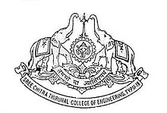

**SREE CHITRA THIRUNAL COLLEGE OF ENGINEERING**

Pappanamcode, Thiruvananthapuram 695018, Kerala

(Established in 1995 under the Govt. of Kerala)

**CAREER GUIDANCE AND PLACEMENT UNIT**

**CERTIFICATE**

***This is to certify that***

**Karthik S B**

**SCT16EC068**

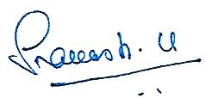**Has successfully completed the Five-day Soft Skills Training conducted by the Career Guidance and Placement Unit, Sree Chitra Thirunal**

**Dr. Sabu VR**

**Placement Coordinator**

***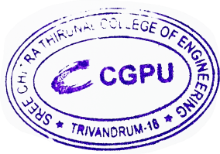*College of Engineering, Pappanamcode, Thiruvananthapuram from 24th to 28th June 2019.**

**Dr. Prakash U**

**Placement Officer**